<http://www.dotnetcurry.com/windows-azure/1387/azure-logic-apps>

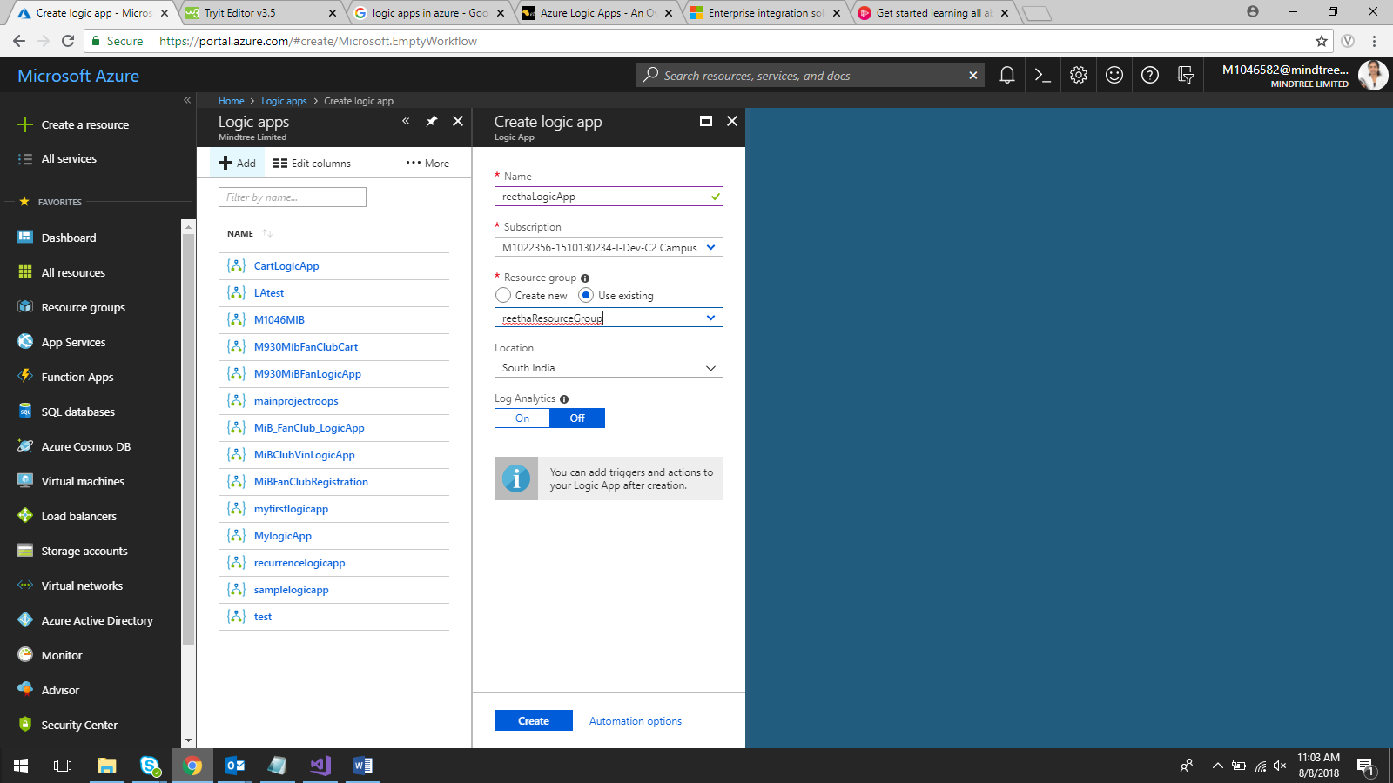

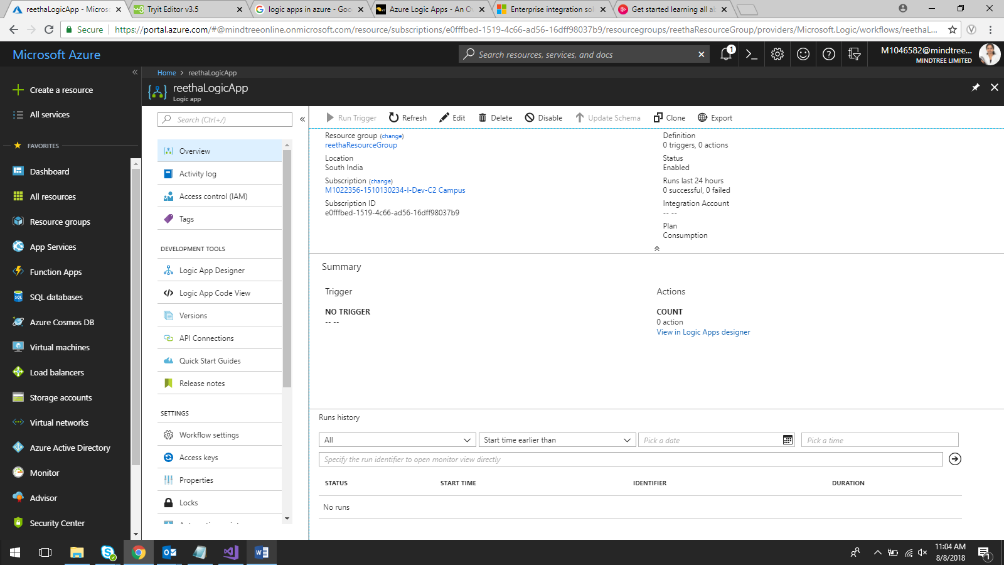

Azure Portal🡪 Cognitive Services

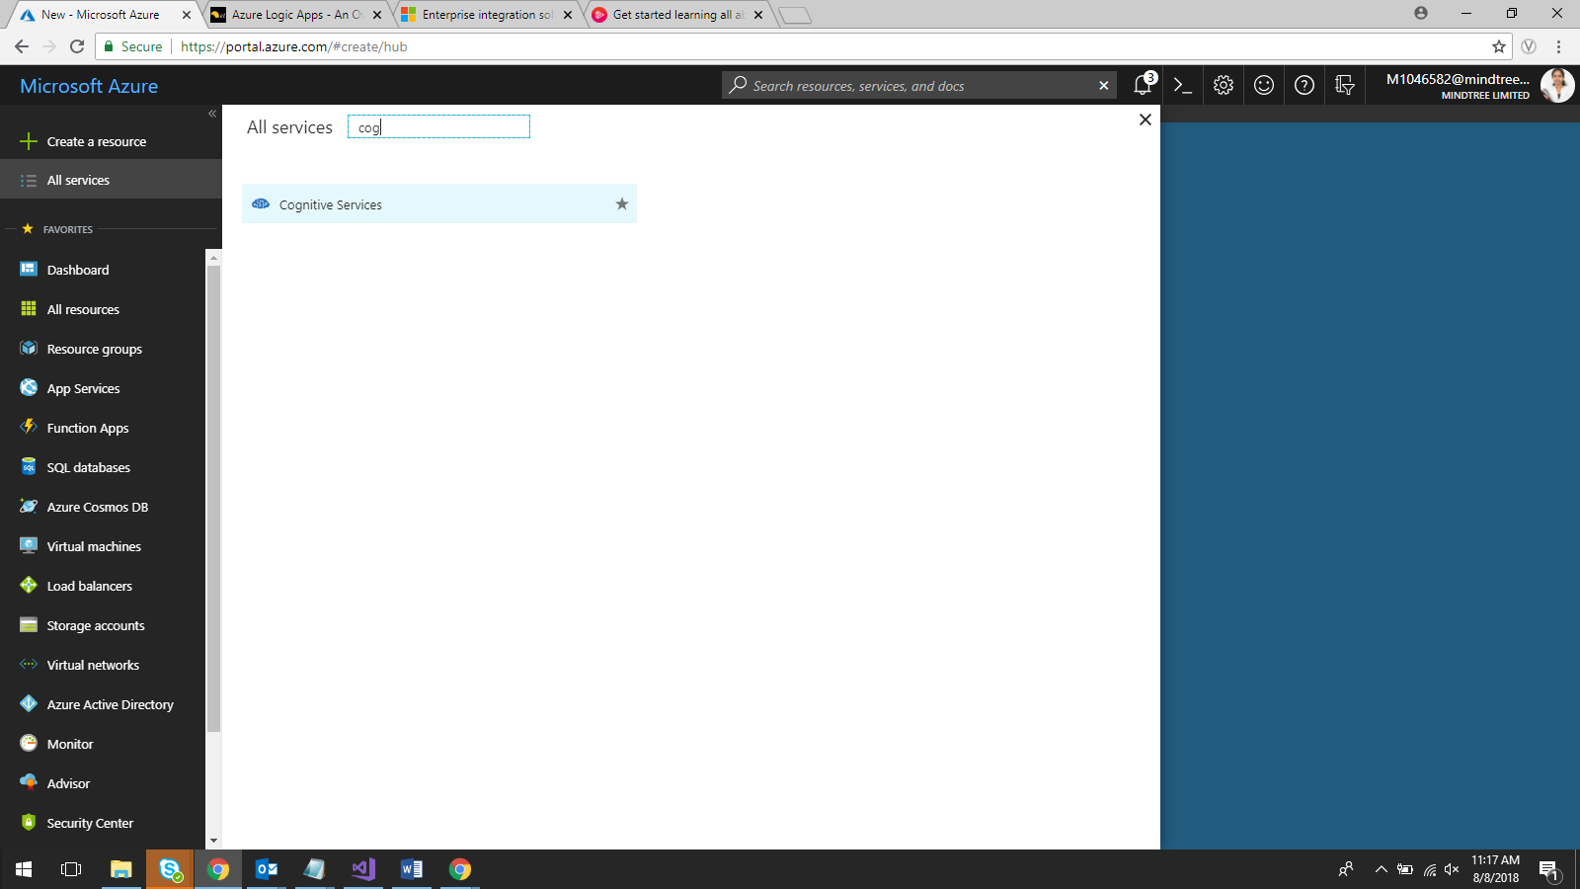

Search Text Analytics

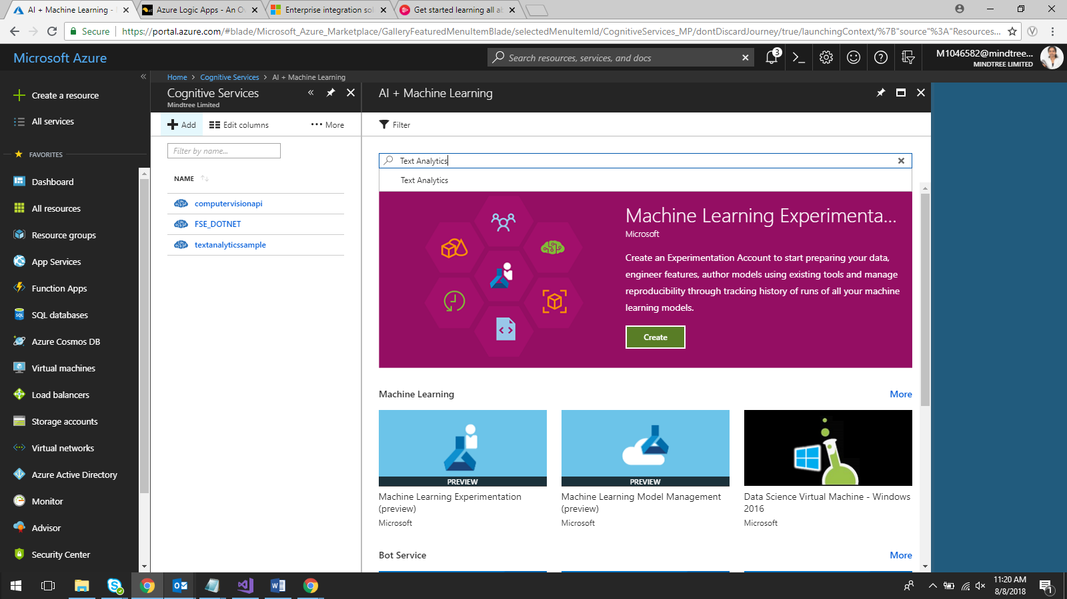

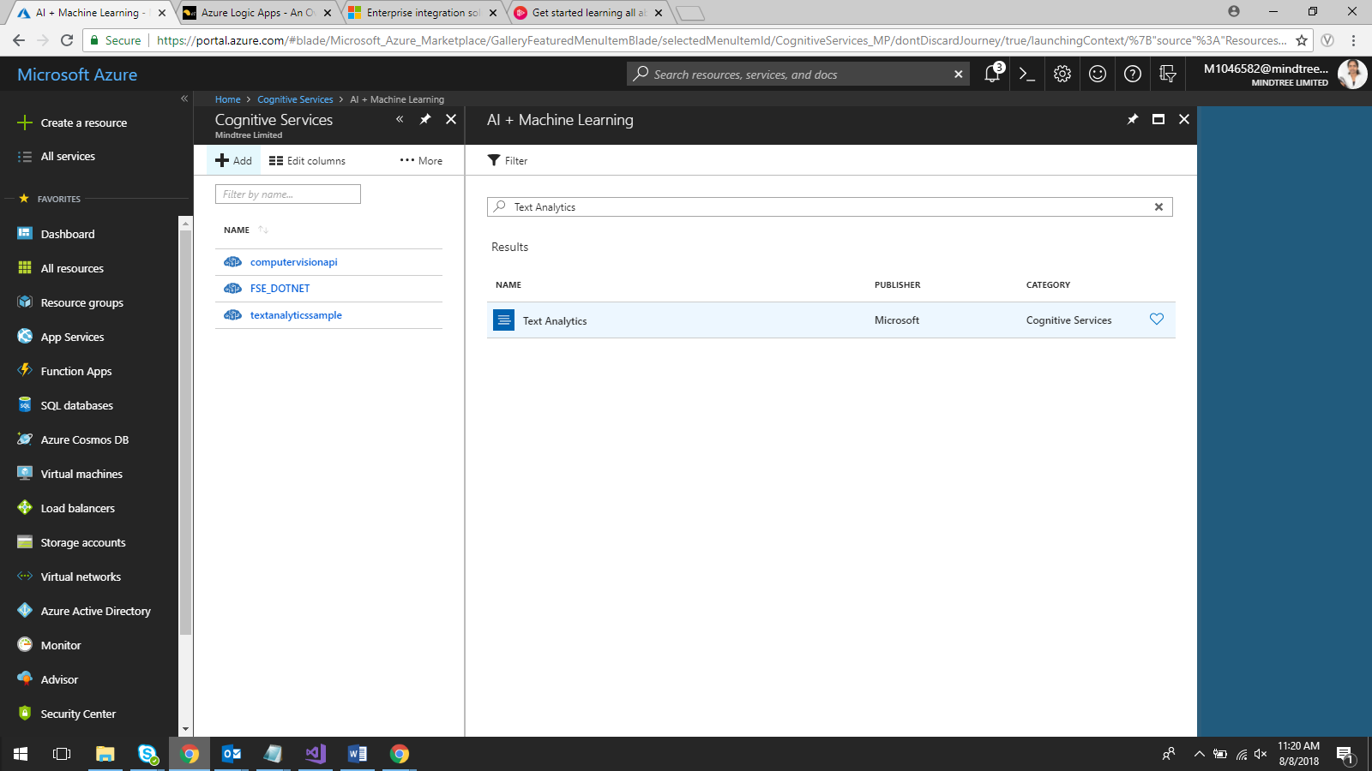

Click on Text Analytics

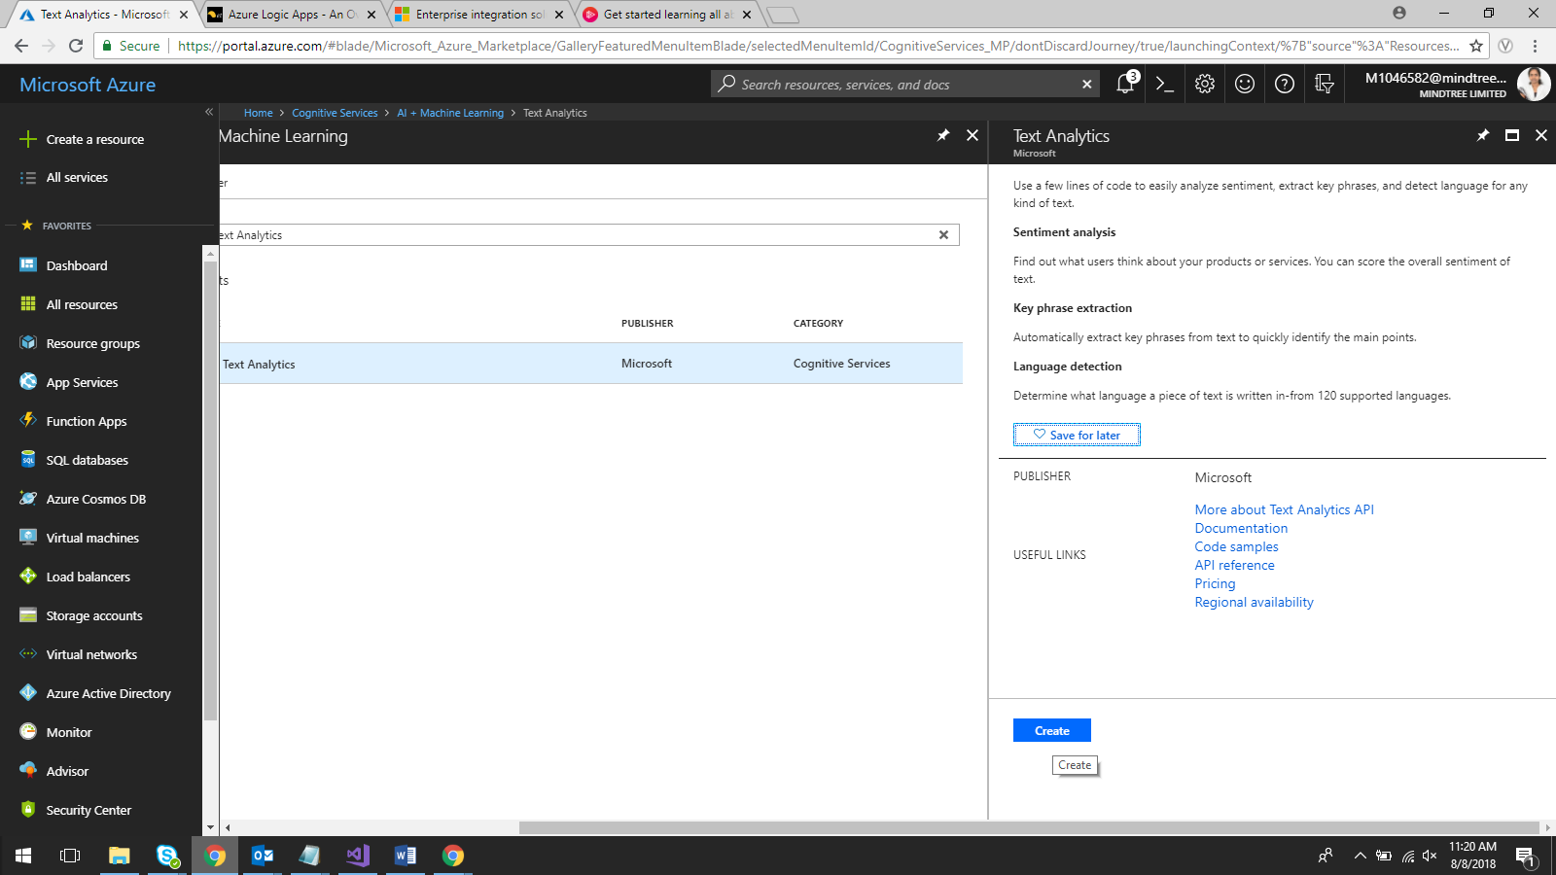

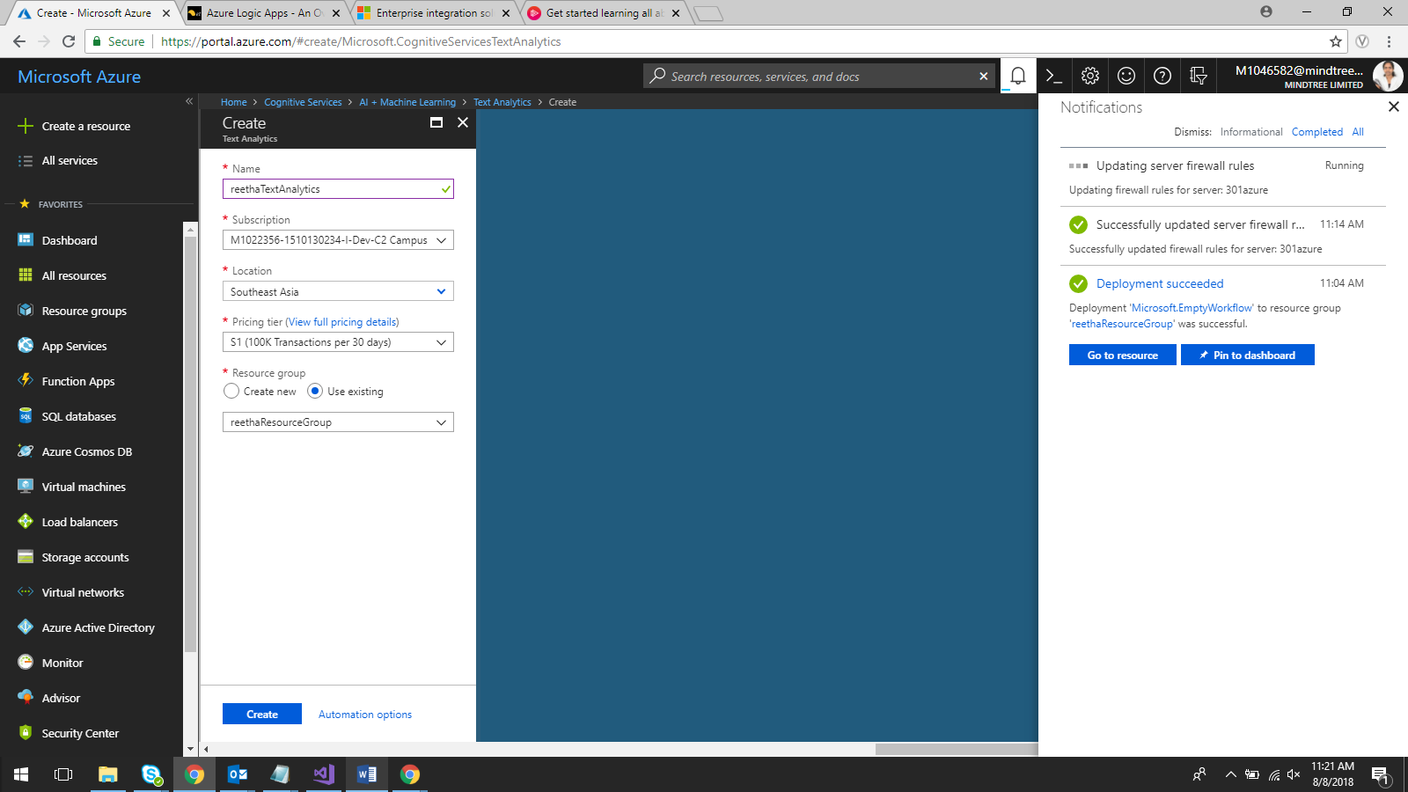

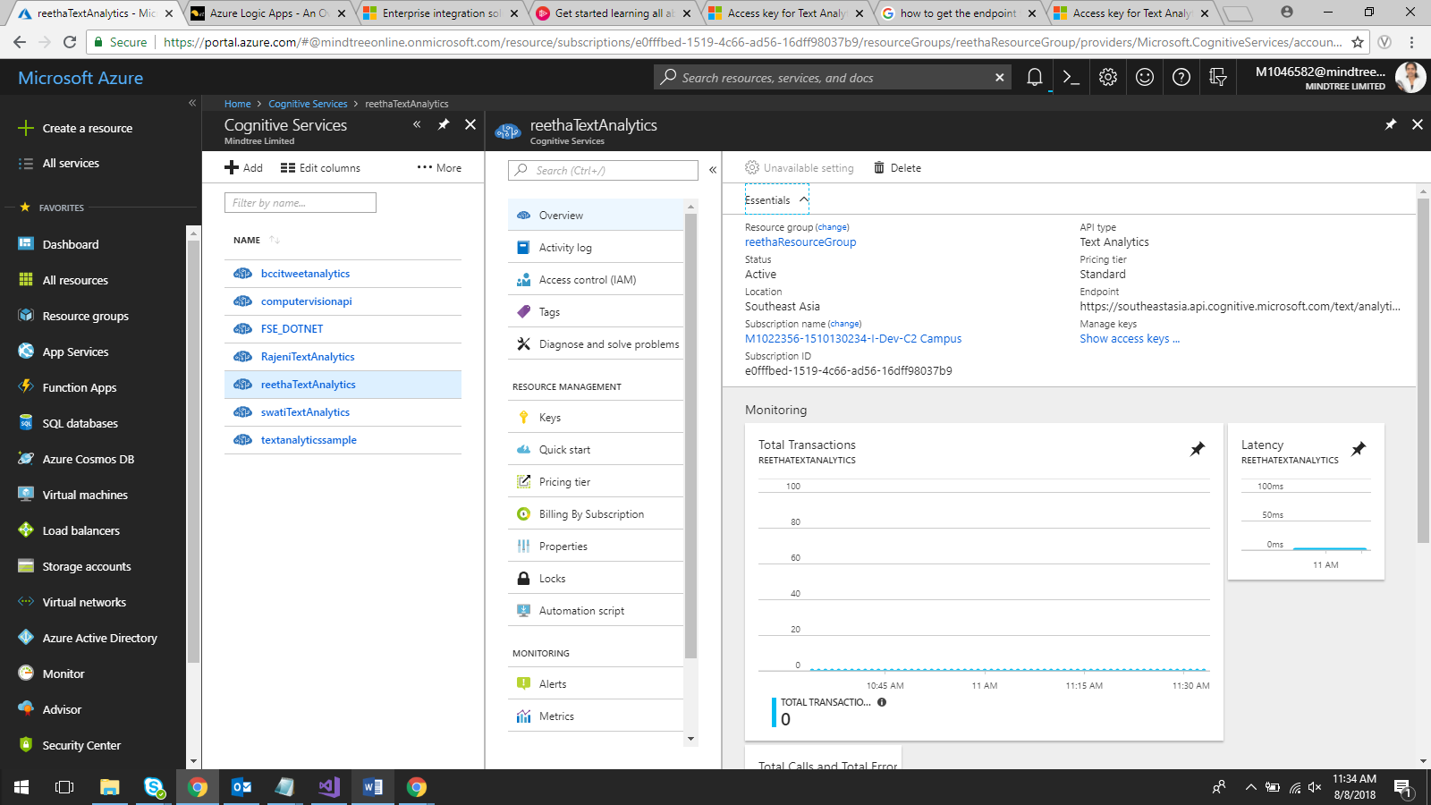

Go to Keys

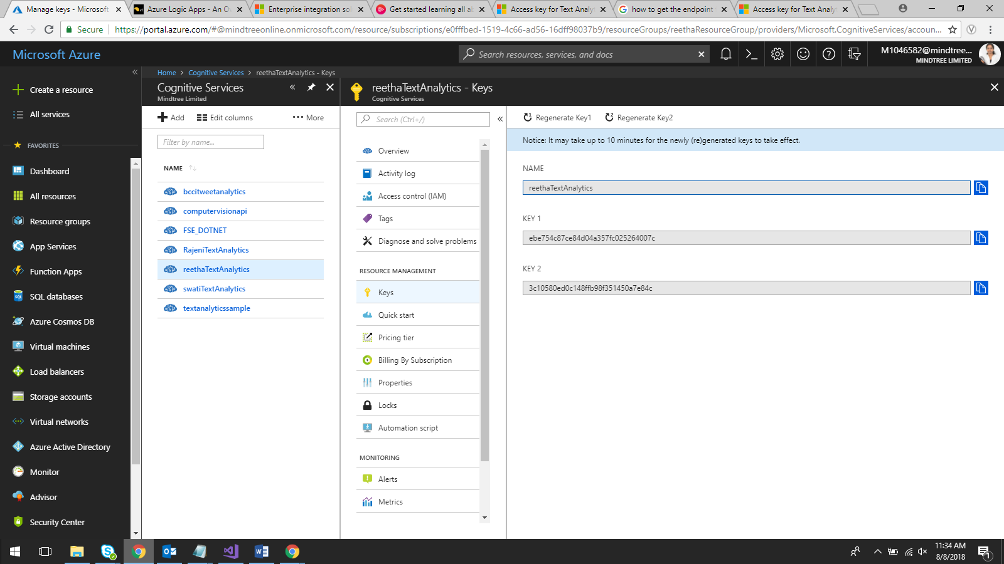

Key : ebe754c87ce84d04a357fc025264007c

Go to Quick Start

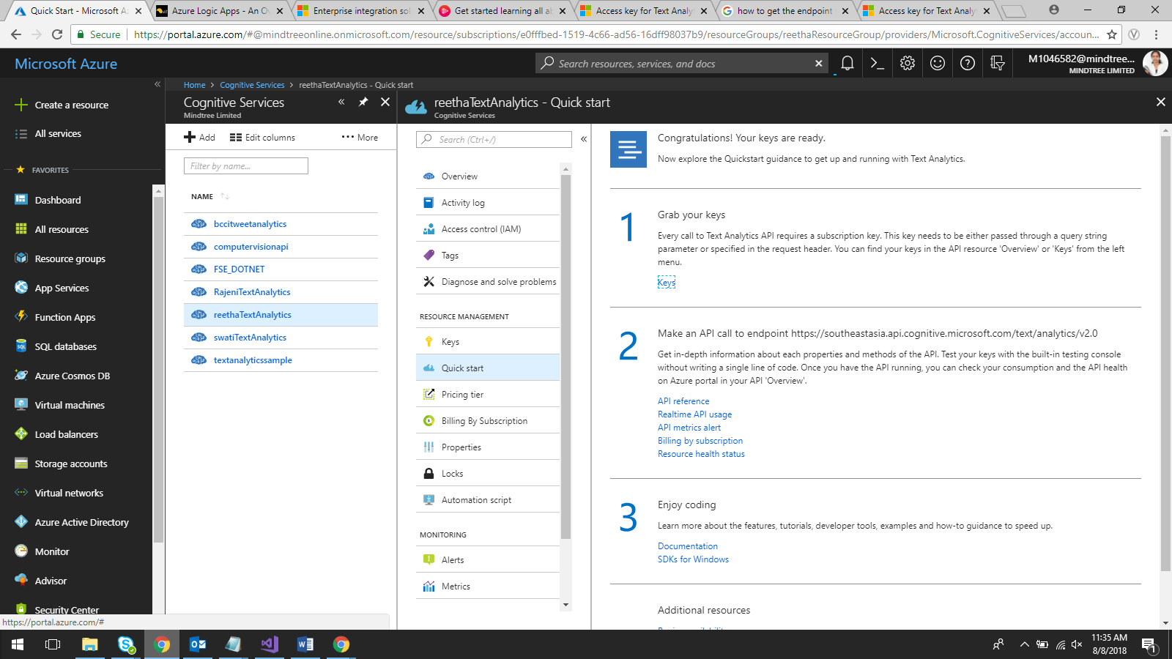

Copy the end point

**https://southeastasia.api.cognitive.microsoft.com/text/analytics/v2.0**

Go to Azure portal 🡪 Logic App you created

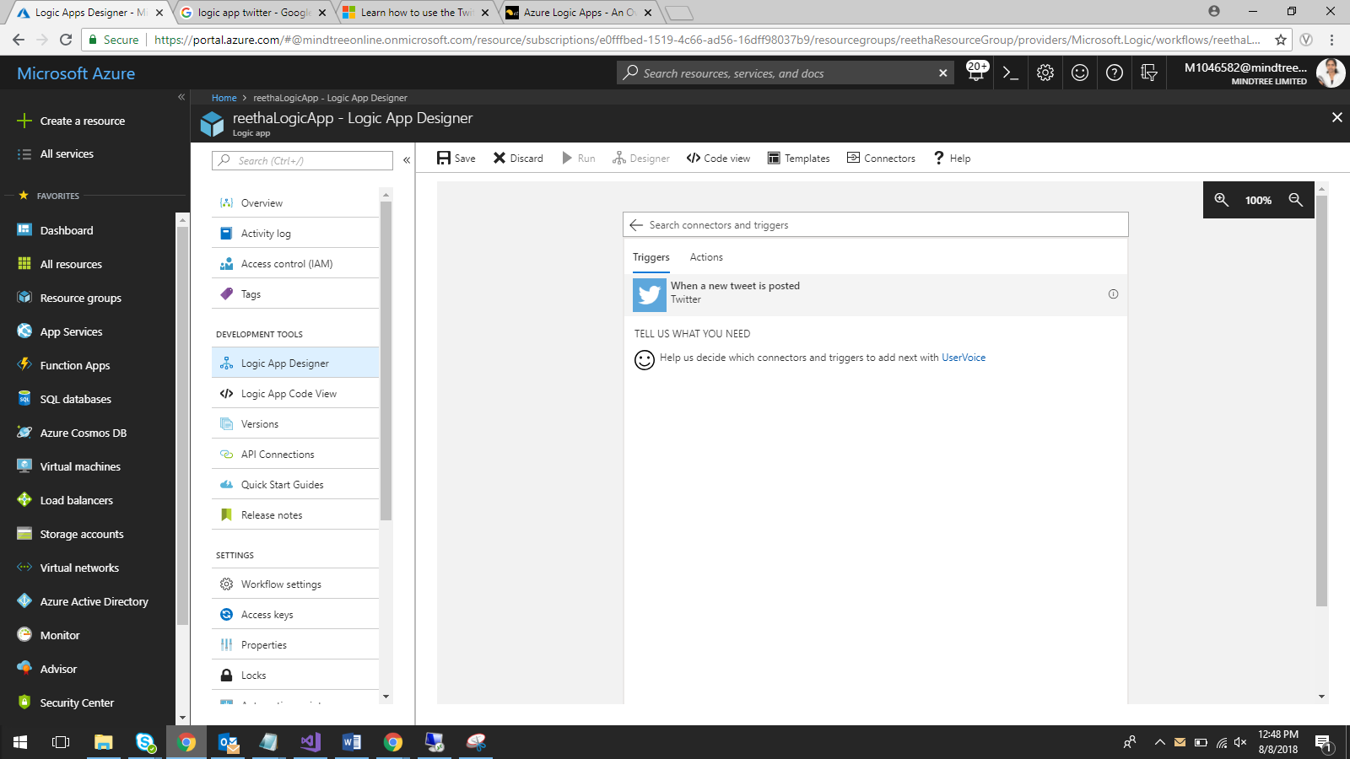

Click SignIn

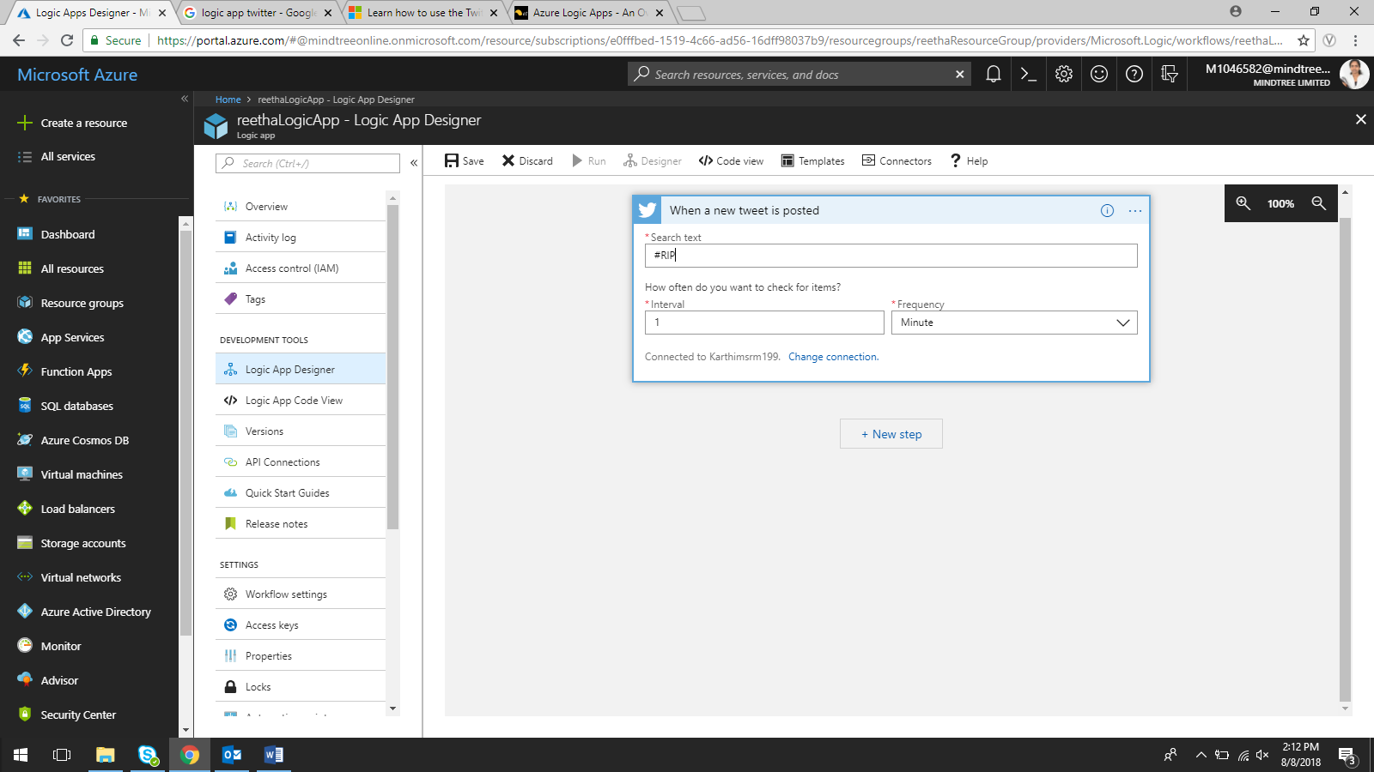

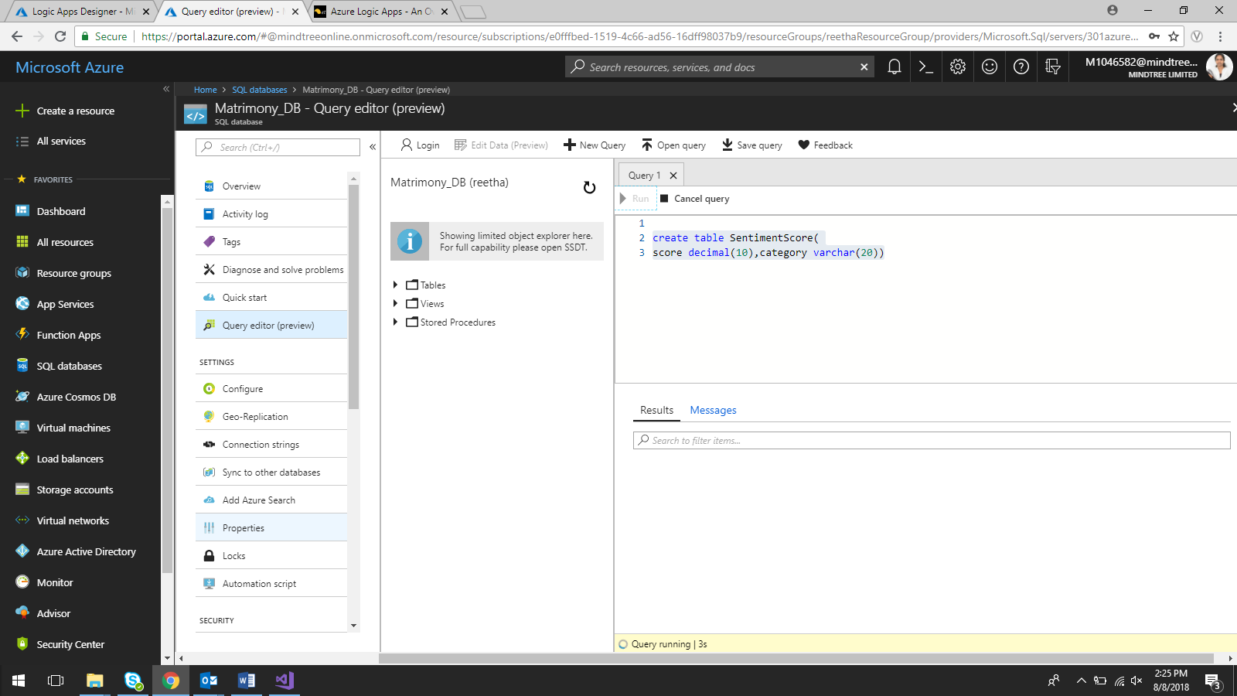

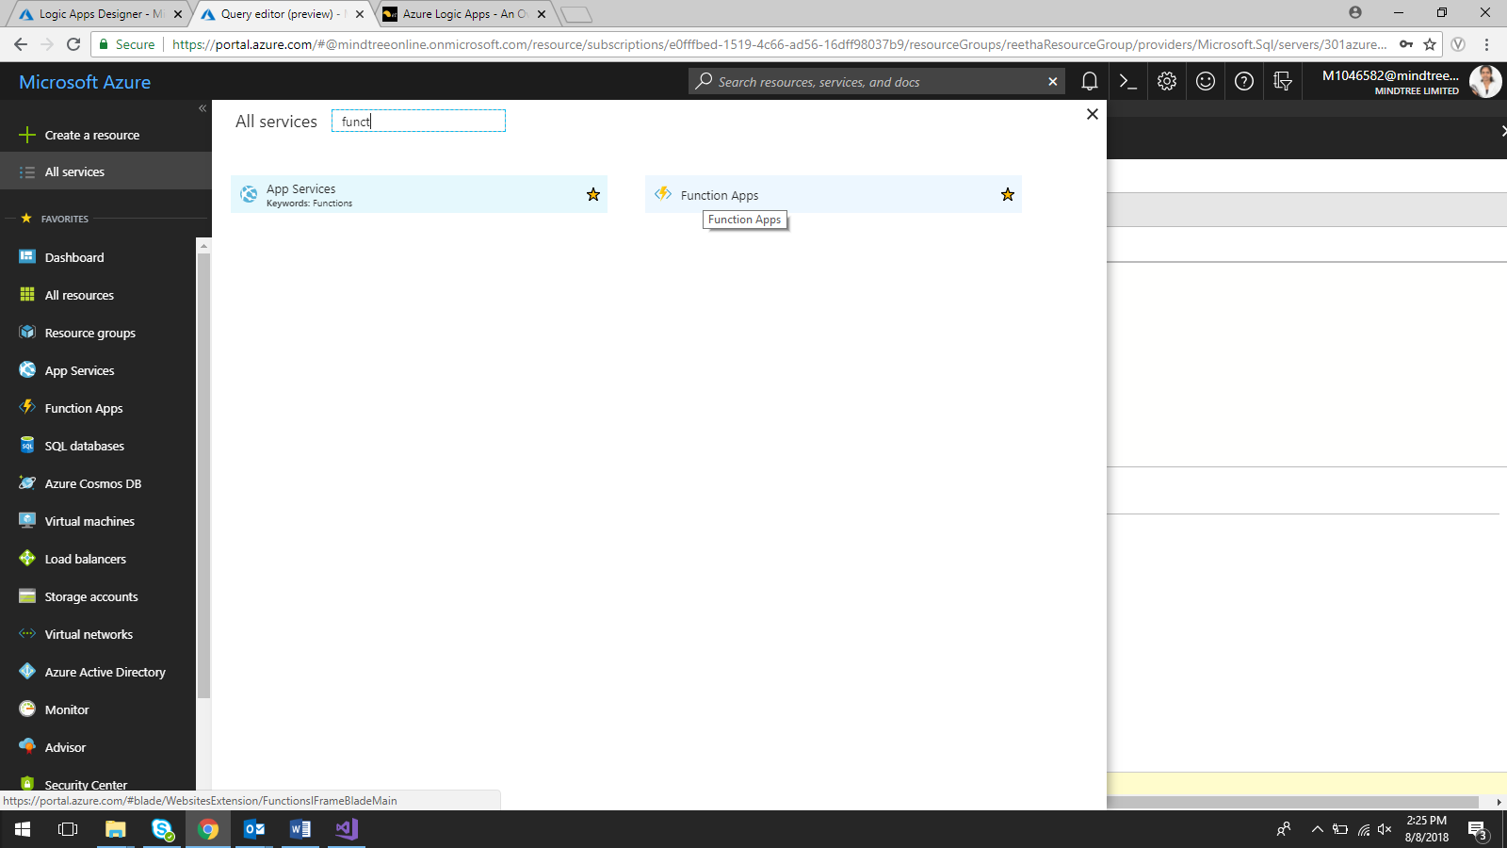

Create function app

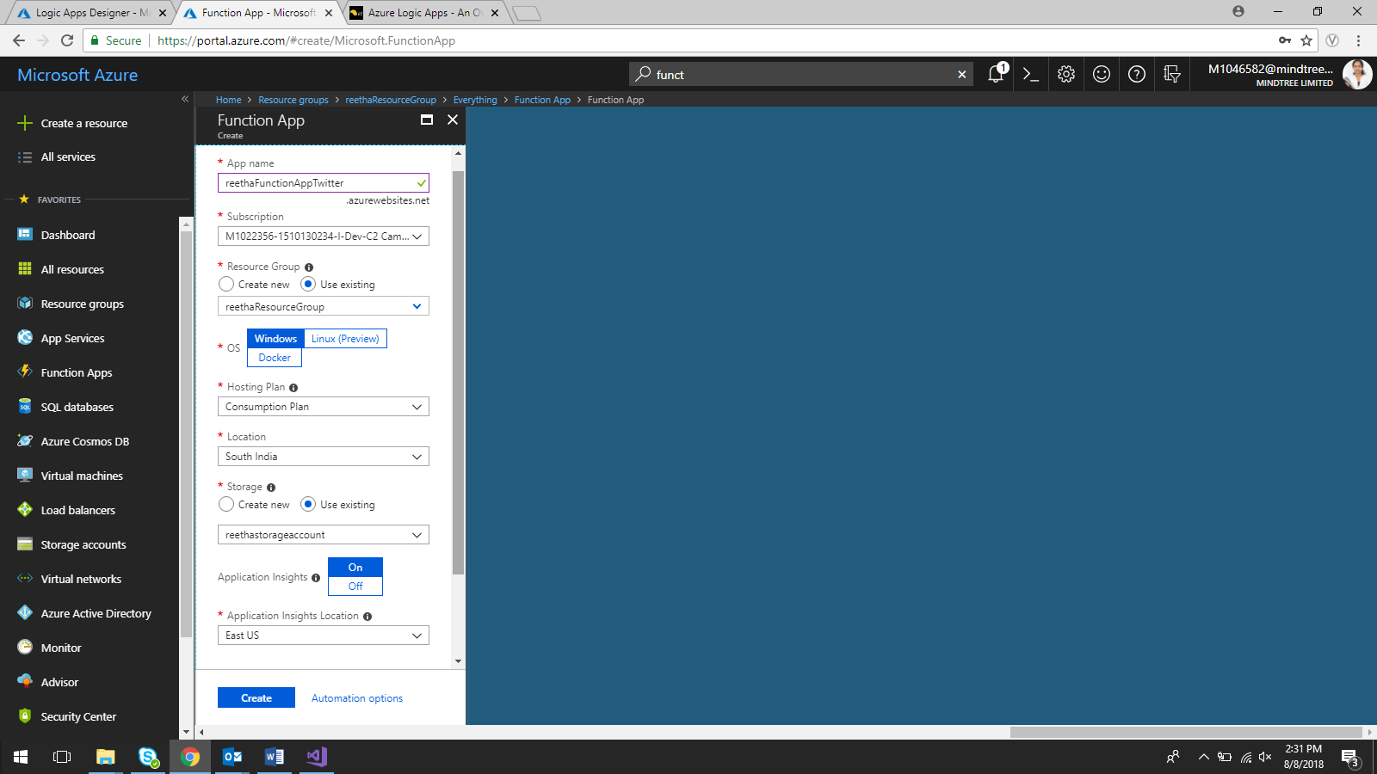

#r "System.Data"

#r "System.Configuration"

using System.Net;

using System.Data.SqlClient;

using System.Configuration;

public static async Task<HttpResponseMessage> Run(HttpRequestMessage req, TraceWriter log)

{

log.Info("C# HTTP trigger function processed a request.");

string category = "Red";

dynamic data = await req.Content.ReadAsAsync<object>();

log.Info(data.ToString());

double sentimentScore;

double.TryParse(data.ToString(),out sentimentScore);

log.Info(sentimentScore.ToString());

if (sentimentScore > 0.3)

category = "Green";

log.Info(category);

var connString = "Server=tcp:301azure.database.windows.net,1433;Initial Catalog=Matrimony_DB;Persist Security Info=False;User ID=reetha;Password=2$Aqwerty;MultipleActiveResultSets=False;Encrypt=True;TrustServerCertificate=False;Connection Timeout=30";

using(SqlConnection logicAppsConnection = new SqlConnection(connString))

{

string insertCommand = "Insert into SentimentScore (score,category) values (@score,@category)";

logicAppsConnection.Open();

using (SqlCommand command = new SqlCommand(insertCommand, logicAppsConnection))

{

command.Parameters.AddWithValue("@score", sentimentScore);

command.Parameters.AddWithValue("@category", category);

command.ExecuteNonQuery();

}

log.Info("Score details added to database successfully!");

}

return req.CreateResponse(HttpStatusCode.OK,category);

}

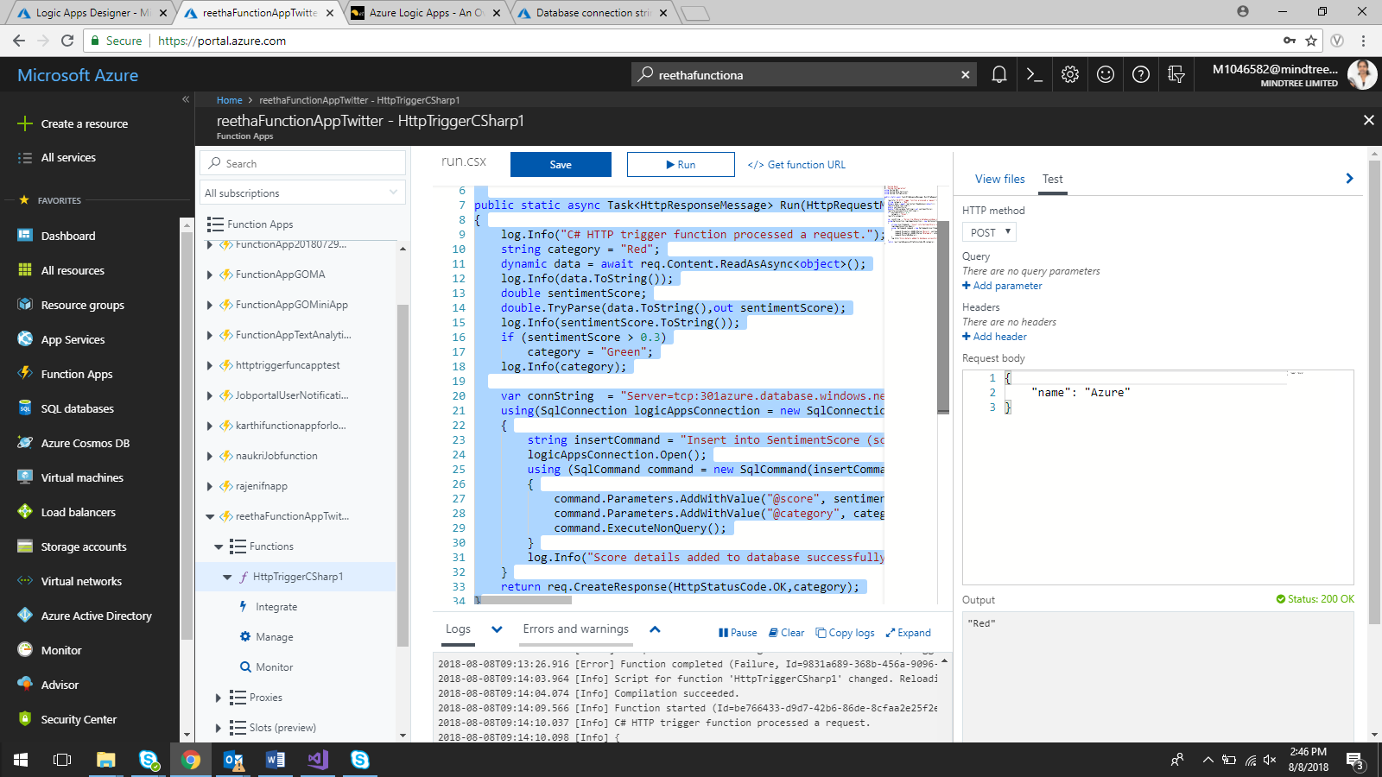

Add Text analytics as new item

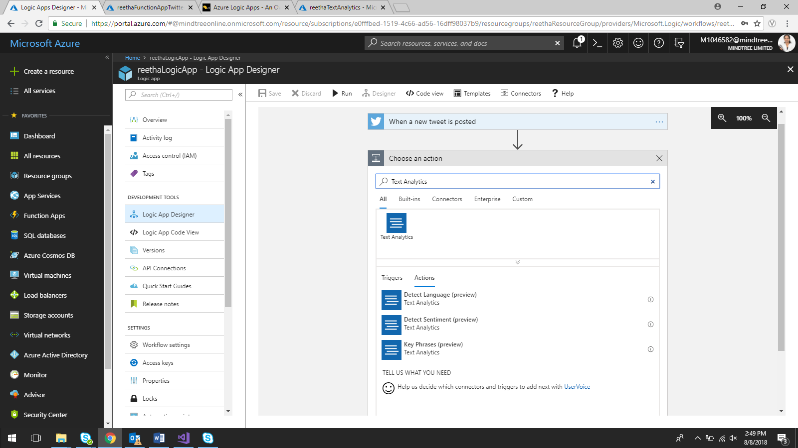

Select Detect Sentiment

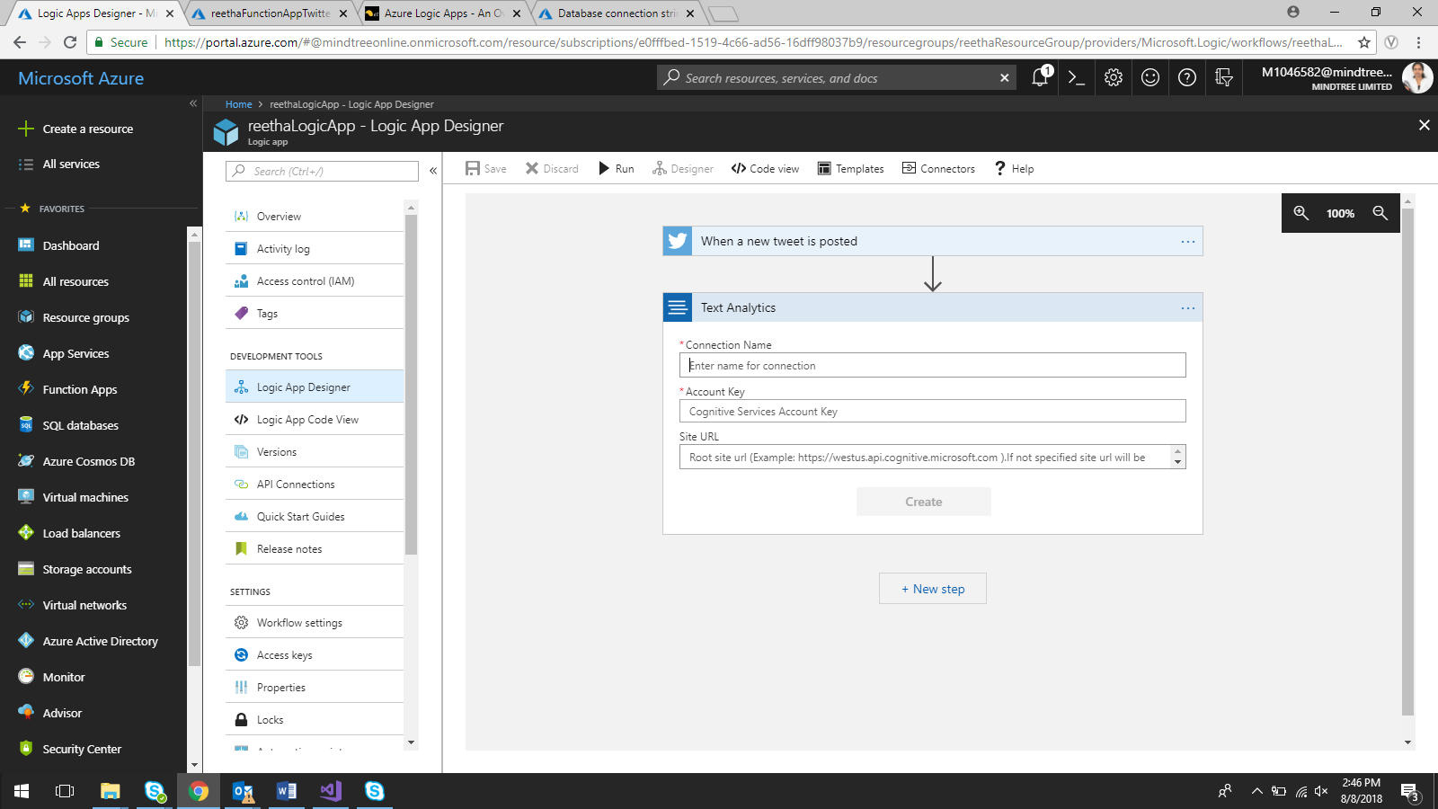

Account key 🡪 Text Analytics key

Site URL 🡪 Text Analytics endpoint URL

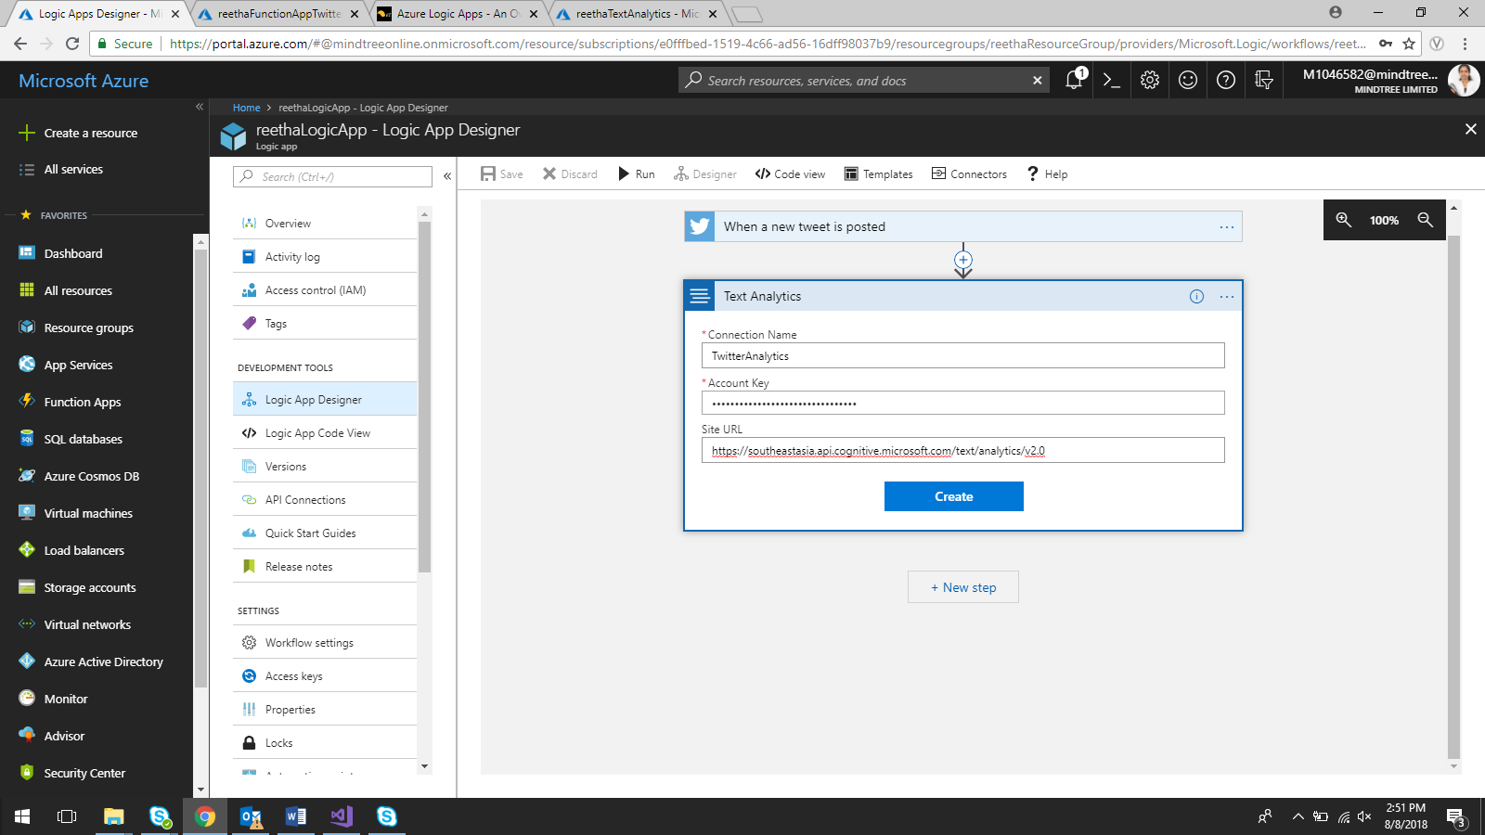

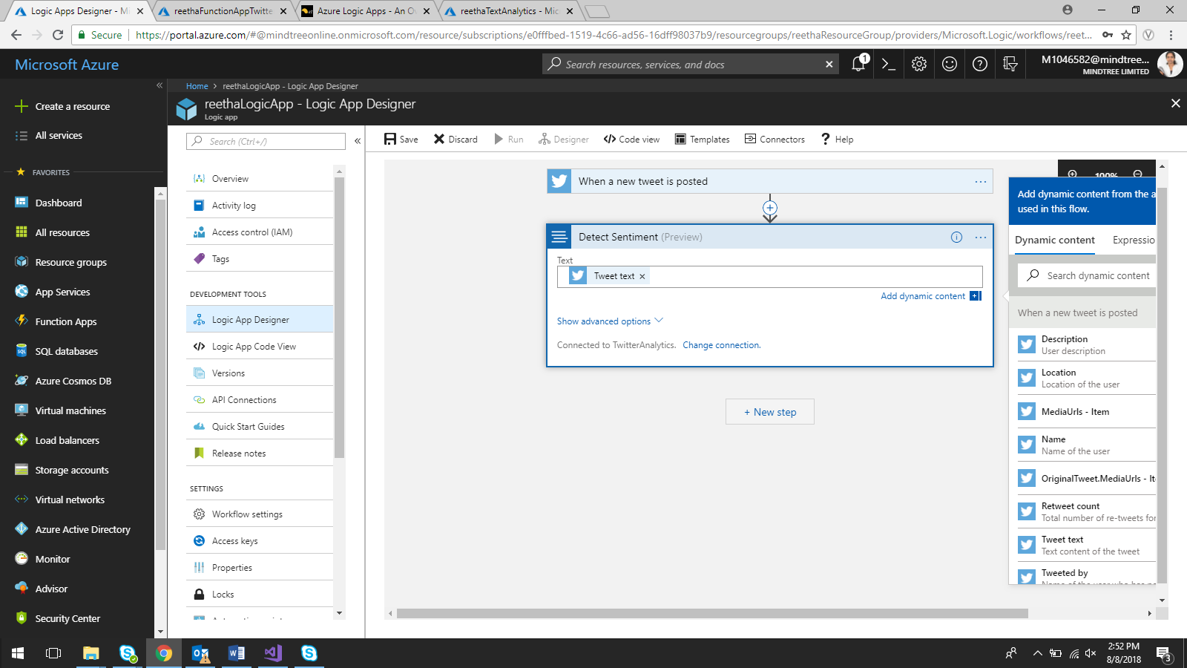

Add New Step 🡪 Select Azure Functions

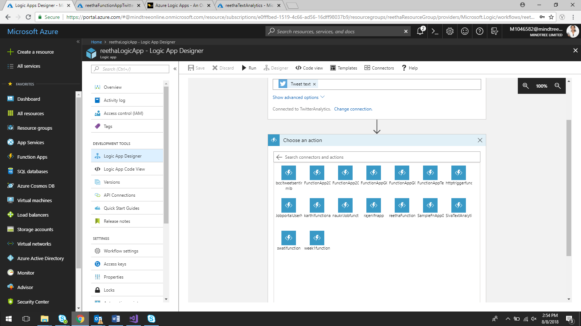

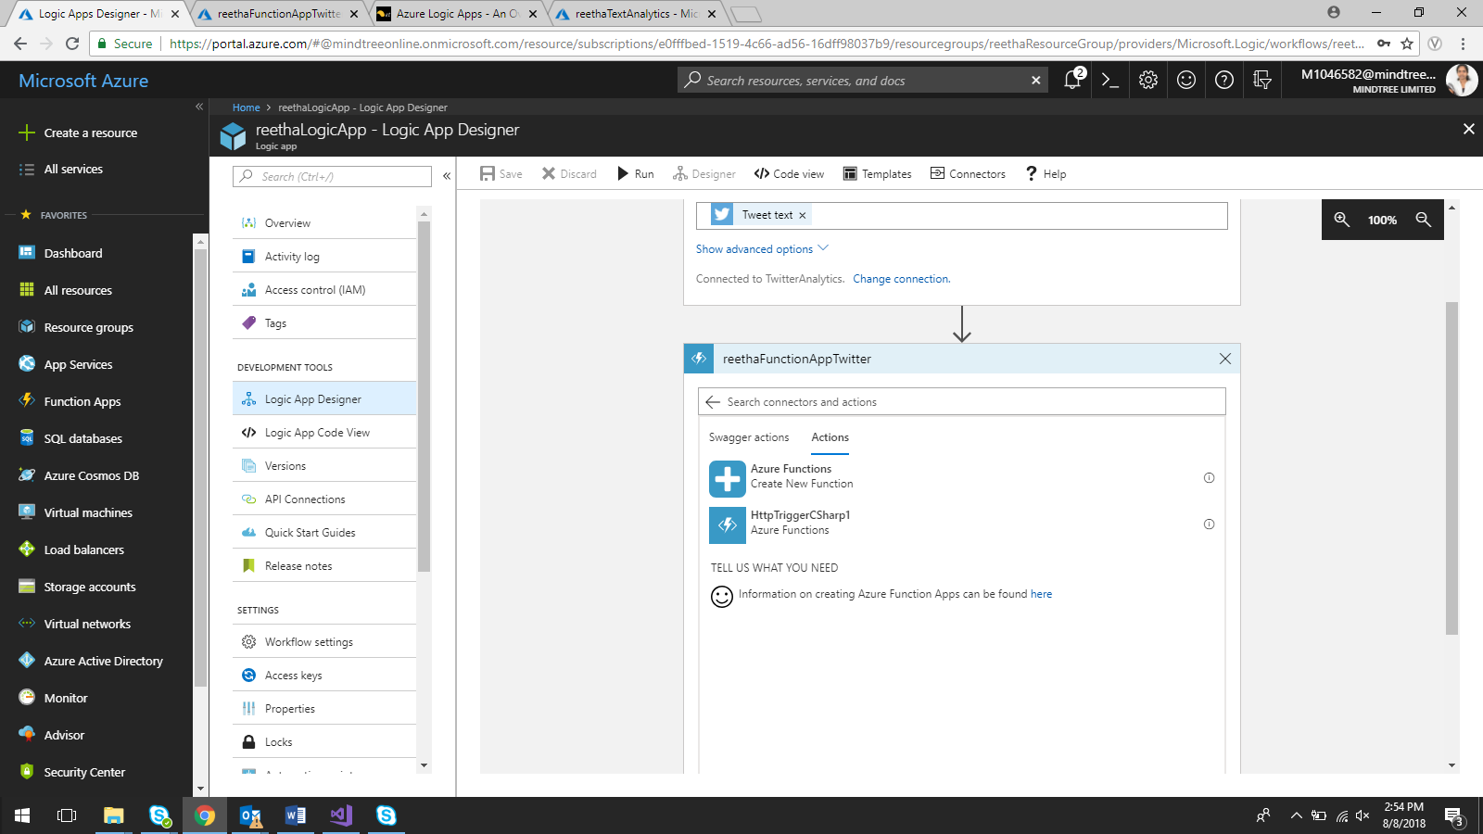

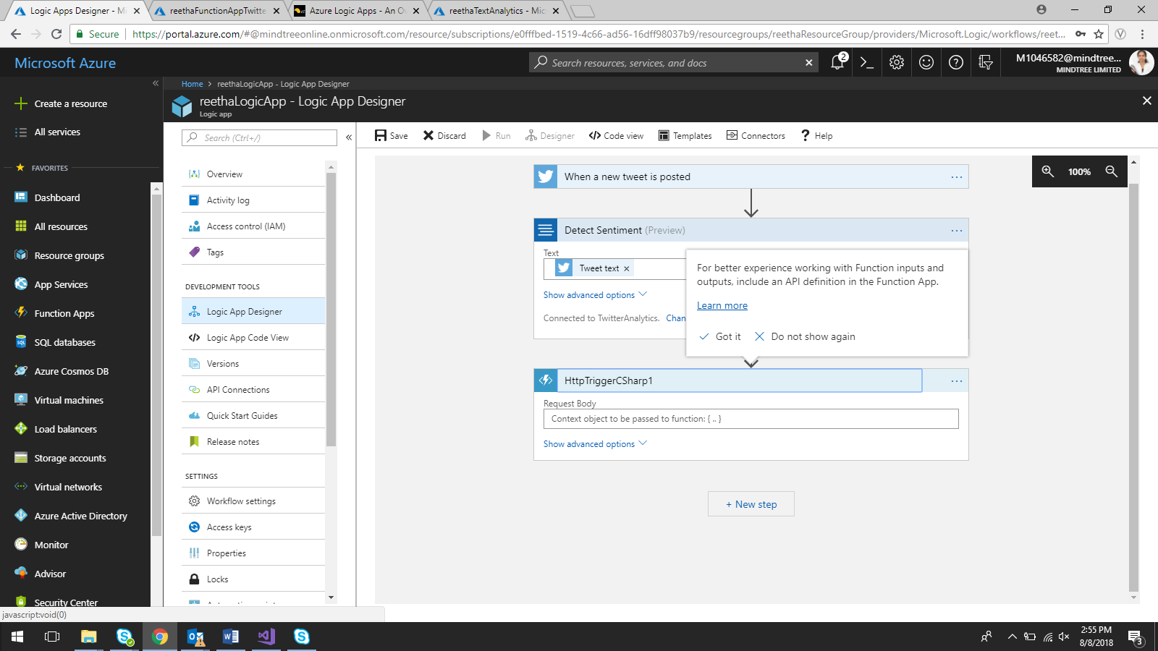

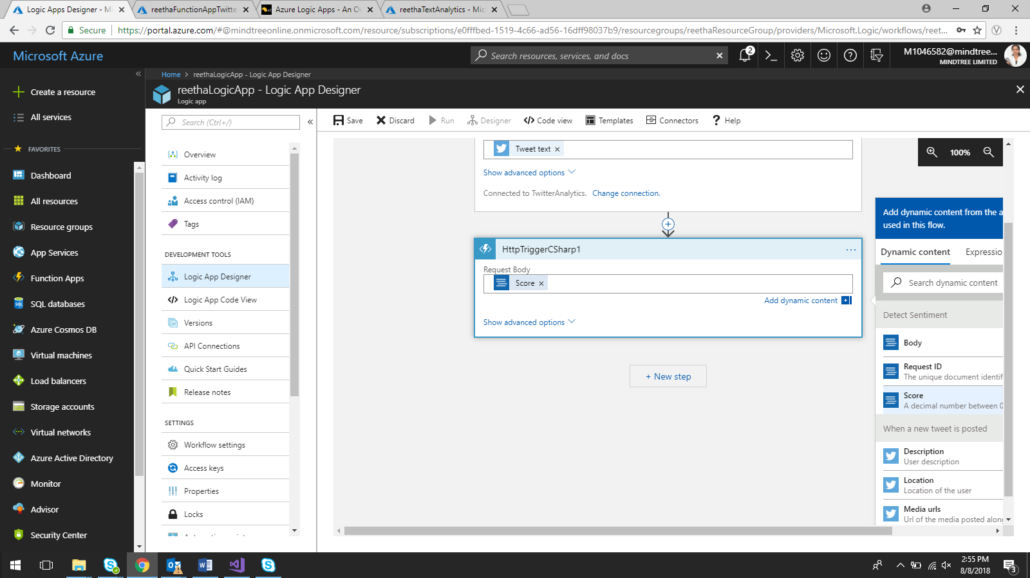

Run the Logic App

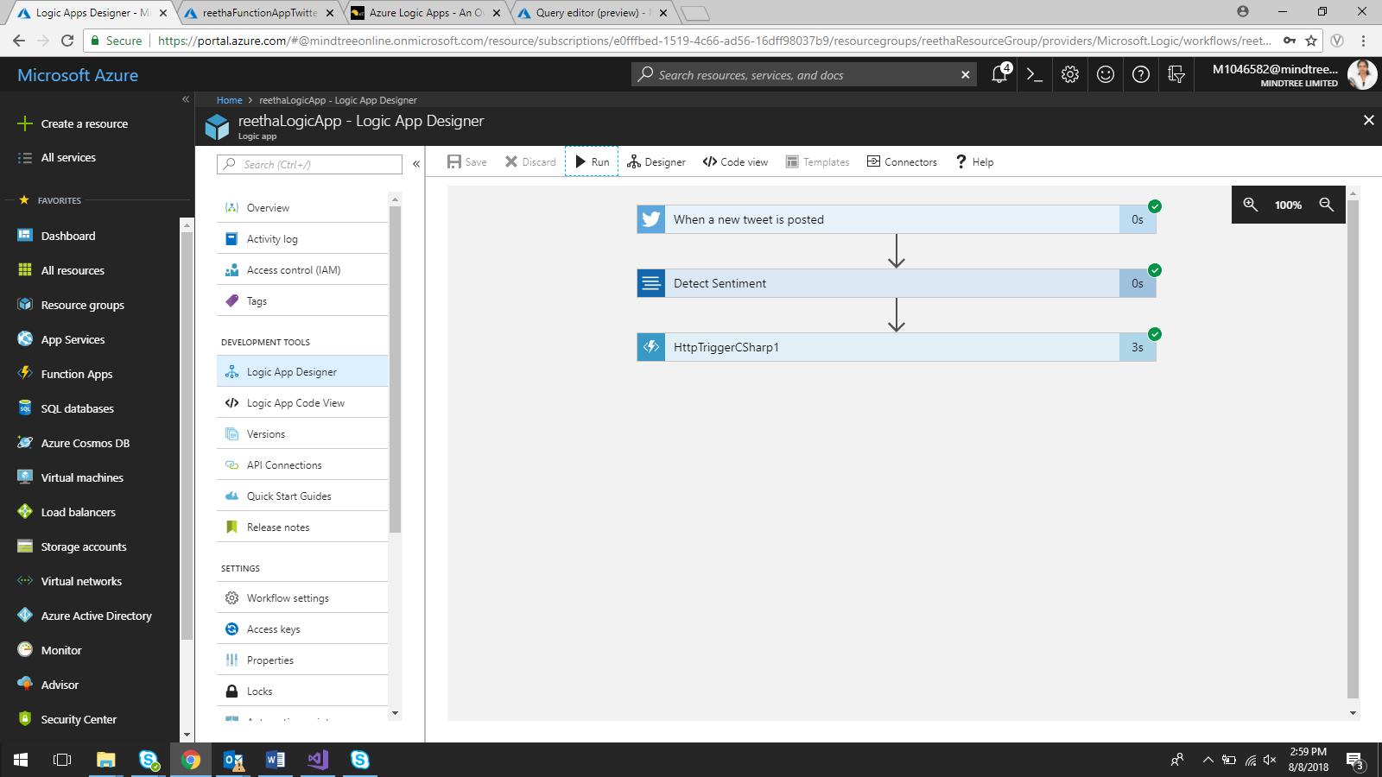

The below table is populated with all the sentiment values based on hashtag configured for sentiment analysis.

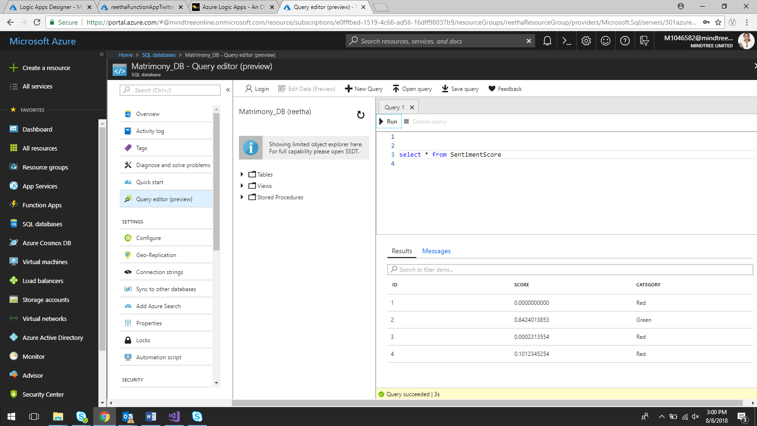

Below were the Twitter feeds we received based on the sentiment analysis for the hashtag #RIPkalaignar #RajajiHall

